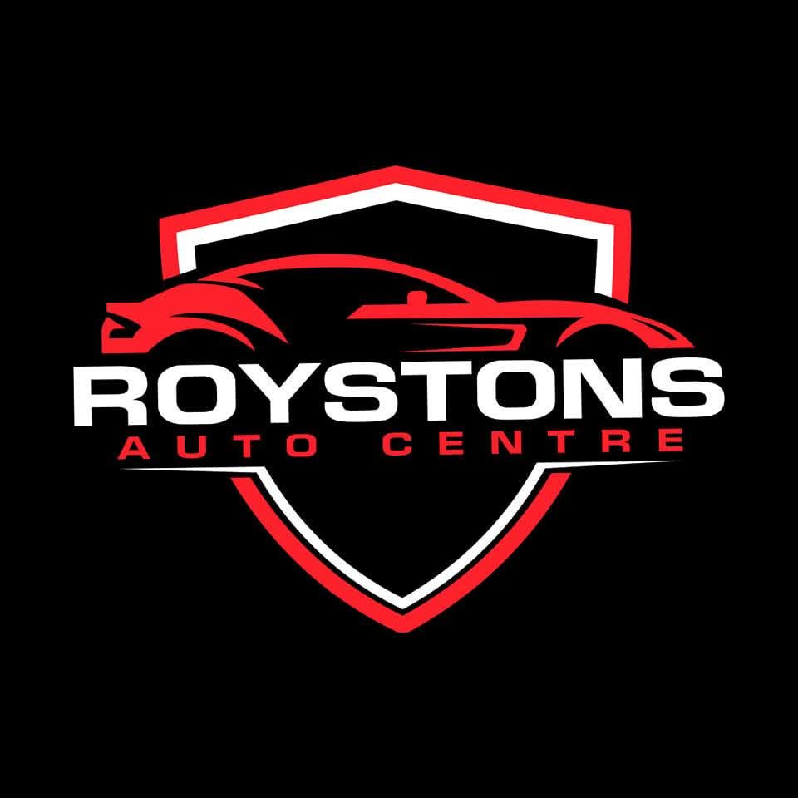 |  | 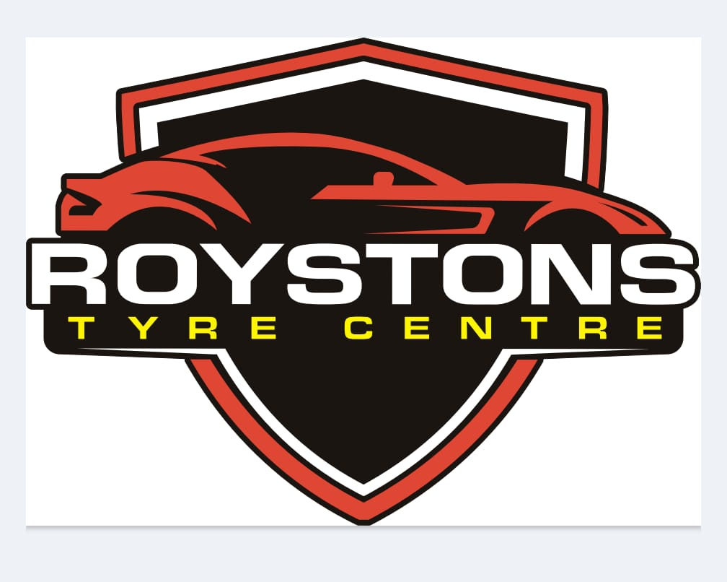
 | 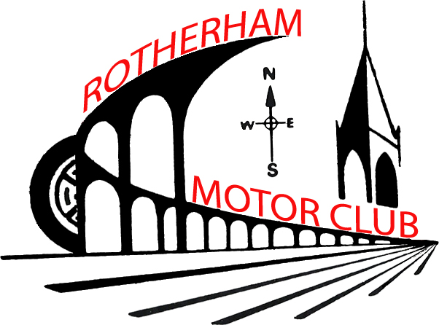

ROYSTONS Auto Centre
AutoSOLO
20th September 2025

Supplementary Regulations

- Rotherham Motor Club Limited will organise a Clubman permit AutoSOLO on Saturday 20th September 2025 at the Wombwell Kart Track, Athletic Stadium, Station Road, Wombwell. S73 0BJ
- The meeting will be governed by the General Regulations of the Motorsport UK, (incorporating the provisions of the International Sporting Code of the FIA), these Supplementary Regulations and any written instructions that the organising club may issue for the event.
- MSA Permit No. TBA applies and will be displayed on the day.
- The event is open to fully elected members of the promoting club and members of the following clubs; Worksop Motor Club, Sheffield and Hallamshire Motor Club, Lindholme Motor Sports Club, Border Motor Club, Wakefield Motor Club, Ilkley and District Motor Club, Cannock and District Car Club, Clowne Motor Club, Loughborough Motor Club, Matlock Motor Club, Owen Motor Club, Selby and District Motor Club, Mid Derbyshire Motor Club, Eastwood and District Motor Club,
- All drivers must produce a current club membership card and MSUK Clubmans Licence (Including Passenger if carried) at signing on.
- The programme for the meeting will be:
Scrutineering opens at 08.15 Closes 09.30
Signing on opens at 08.15. Leave time to walk the first test.
Drivers’ briefing 09.45. Note: Any competitor not signed on by 09.30 will not be allowed to enter.
First car starts at 10.00.
Event will finish approx 16.00.
The Course will be depicted by cones. Designs will be handed out at successful signing on.
- Classes for this event will be as follows;
A. Production Front Wheel Drive Saloon and Sports Cars
B. Production Rear Wheel Drive Saloon and Sports Cars.
C. All other cars, including Specials (including rally-prepared cars, kit cars, etc)
And all four wheel drive cars.
The minimum class entry is 3. If the class minimum is not reached the organisers reserve the right to amalgamate classes.
“Production cars” are those running with original panel and window materials although additional panels, e.g. wheel arch extensions and accessories may be added. They must have full trim and seats although type may be replaced. The original manufacturer’s engine type must be fitted in the original position but it may be tuned. Suspension may be altered within its original configuration. Commercial variants of production cars, e.g. vans, will be allowed, as will electric vehicles and will run in their respective classes.
“Specials” means cars not complying with the above (Anything not production) (e.g. Welded Diff’s) (Added Turbo’s) (If you’re unsure Telephone Event secretary David Winter 07785565161)
Modified Forced-induction petrol engine cars will be in Class C.
Forced Induction Production Petrol/Diesel Vehicles will be in their drive wheel category.
- All vehicles will comply with MSA Technical Regulations. All vehicles must be taxed and insured for the public road. Proof of a current MOT must be produced at scrutineering: exemption can only be given to vehicles less than 3 years old, for which proof of registration date will be required. Vehicles must compete on road legal tyres. List 1a tyres in the 2024 Competitors and Officials Yearbook (List can be found at www.msauk.org.) are not permitted. All vehicles must have been driven to the event – there is no parking for trailers. Please note that tyre wear may occur, especially on front wheel drive cars, and you should ensure that you have legal tyres on which to drive home.
- Awards will be presented as follows:-
First Overall
First in each class (subject to 3 starters)
In the event of a tie, the fastest run on the first course will determine the tie, then the fastest on the second course, etc until the tie is decided. To be classed as a finisher, a competitor must start at least one run at all of the courses.
No competitor may win more than one award.
- The secretary/Entries Secretary of the meeting is. David Winter. Tel: 07785 565161. On line entries can be found in this link; https://www.rotherhammotorclub.com/royston-motors-autosolo-20-09-2025/
- Entries open on publication of this regulation and close finally on Monday 26th May 2025. No entry will be accepted without both an official entry form and payment of the appropriate fee. The entry fee for this event is £40.00. Please make payments by BACS Payments: payable to “Rotherham Motor Club Ltd” Sort Code: 05-04-38. Account Number 54937104. Use Reference Autosolo: Also add your surname. Entries will be acknowledged by e-mail only. Late entries may be accepted up to 09.00 on Monday 15th September 2025 subject to the entry list not being full. Entries will be accepted in order of receipt of payment. Entries may be accepted from drivers between the age of 16 and 17 or over 17 without a Road Traffic Licence, but they may only drive a car in class A or B and be competent to drive in the opinion of an accompanying person with a full driving licence.
- The maximum entry for the event is 30. The minimum is 25. Should the minimum figure not be reached the organisers reserve the right to cancel the meeting. The minimum class entry is 3. If the class minimum is not reached the organisers reserve the right to amalgamate classes. A car may be driven by two different drivers, but a driver may only drive one car.
- Event Officials are:
Club Steward TBA
Clerk of the Course Andrew Lawrence (Tel: 07909 704907)
Scrutineers David and Reece Lumbley
Chief Timekeeper Michael Royston
Chief Marshal David Wood
Timekeepers David Winter and Richard Johnson
Results & Safeguarding Officer Keith Winter
Driving Standards All Marshalls
- Provisional results will be published as soon as possible following the end of the event and awards presented on the day. Results will also be displayed throughout the day on completion of a course.
- Any protests must be lodged in accordance with MSA regulations.
- Competitors will be identified by numbers provided by the organisers. They must be displayed on the rear side windows or closest equivalent place.
- Marking and penalties will be as follows:

1.Time taken competing the course | Actual time taken
2.Striking a cone or barrier or any other course marker defined on the diagram | Actual time taken plus 5 seconds per offence. (Up to a maximum of 4. Then Incorrect Test)
3. Taking an incorrect route on any course. (This does not cover returning to the point of departure from the correct route and then completing the course correctly) | Maximum Time
4.Completing the course but exceeding the maximum time | Maximum Time
5.Not stopping immediately on deployment of the STOP signal | Exclusion
6. Not stopping astride finish line | 10 seconds
Note: The Maximum Time is the fastest time in class for that run plus 30 seconds.

- A single course will be laid out. It is planned to run two courses and to have a maximum of six runs at each course. All tests to count. The STOP signal will be displayed because of an obstruction on the course, whether this is an object or personnel. A competitor must stop immediately on deployment of the STOP signal and a re-run will be allowed.
- The STOP signal will be demonstrated at the drivers briefing.
- The starting signal will be “In your own time”.
- Timing will be by hand-held stopwatches to the previous tenth of a second.
- Timing will start when the leading wheels cross the timing line and stops when the leading wheels cross the finishing line. Competitors must stop astride the line.
- All other General Regulations of the MSA apply as written except that:-
a) All competitors can walk each test before the timed run starts for that course.
b) No practicing will be allowed.
Notes
Passengers do not have to be carried. But if carried at the start of the event, they must be carried for all timed tests.
Drivers can compete from 13 years of age see NCR Ch.19 App.6 Art.4 (19.6.4)
Entries may be accepted from Drivers who are aged 13 years and over and at least 135 cm in height (subject to any medical disability exemption) Please see NCR’s for further information. (Only certain cars can be used)
(M) 4.1.(c) An effective windscreen or Aero-type screen must be fitted.
(M) 21.1. A passenger can be carried in all timed tests (alongside the driver)
(M) 21.6. The passenger in a Touring Car or Cabriolet/Sports Car with the hood erected or a hardtop fitted, must be aged 12 years or over and be at least 135cm in height.
(M) 21.7. The passenger in a Cabriolet/Sports Car without the hood erected or hardtop fitted must be aged 16 years or over and be at least 135cm in height.
Safety Requirements.
All seat belts MUST be worn at all times on test, worn as the manufacturer intended.
No hand brake turns between the tests.
No heavy or sudden braking between the tests including tyre warming.
No sudden accelerating between tests.
No holding back to do your tests.
Windows to be open no more than 4 inches whilst on test.
If any of the above are broken, then a 30 second penalty will be applied at the end of the event and or Exclusion. (This is for your safety and that of others)

